MEMORANDUM

To: Traci Gardener

From: Dennis Devlin, Robert Lindh, Andrew Hug Date: 3/26/2025

Subject: Revision for HokieSpa

## Introduction

Trying to register for classes, check financial aid, or manage tuition payments should be simple. But for students and faculty at Virginia Tech, using HokieSpa can be frustrating. The website, which is supposed to help with these important tasks, is difficult to navigate, has an outdated design, and doesn’t work well on mobile devices. These issues make it harder for users to complete tasks quickly and efficiently. Our team is proposing a project to analyze HokieSpa and suggest ways to improve it. We will gather feedback from students and faculty, research best practices, and come up with solutions to make the site easier to use. By improving navigation, updating the design, and making it more mobile-friendly, HokieSpa can become a much more effective tool for everyone at Virginia Tech. In this proposal, we will explain the main problems with HokieSpa, outline our research methods, and present our recommendations. If our ideas are implemented, the website will be more user-friendly, reducing frustration and making it easier for students and faculty to access the information they need.

# Overview and Rationale

Our group proposes to analyze and recommend usability improvement for HokieSpa, a online portal managed by Virginia Tech. HokieSpa serves as the primary website for students, faculty, and staff to access academic records, register for courses, manage financial aid, and handle billing tasks. Despite the site’s importance, it suffers from usability issues that hinders the sites effectiveness, including:

* **Complex Navigation:** Overlapping menus and unclear pathways make the site very difficult for users to navigate and complete tasks efficiently.
* **Outdated Interface:** The design of the site is missing modern visuals. This leads to a cluttered and frustrating experience.
* **Poor Mobile Optimization:** With many people using smartphones to view websites, this website’s limited responsiveness creates difficulty.

Improving HokieSpa will streamline user interactions, reduce the support demands on Virginia Tech’s IT department, and enhance the university’s digital reputation.

## Project Methodology and Resources

Our group plans to conduct research based on the different complications that HokieSpa may prompt students and faculty to experience. We will conduct the research based on surveying students and faculty as well as online research to better our understanding. We will use this information to think forward about how to directly face these problems. By doing so, we will be able to develop a more effective site to improve navigation, outdated technology, as well as optimization.

Our group plans to use various websites and articles to help us better understand and identify the issues of the HokieSpa website. These websites and articles consist of Clearscope for practices of Updating website information and the Nielsen Norman Group to help communicate and navigate through the site more efficiently.

## Project Audience

This project is intended for Virginia Tech's IT administrators, specifically the ones responsible for overseeing and maintaining HokieSpa. The primary audience in this case would be the team that is responsible for the development and maintenance of HokieSpa. This team has the ability to implement changes to the site and would benefit the most from our usability recommendations. The secondary audiences would be the university administrators who oversee digital services, since their support may be needed to prioritize these changes. Our recommendations will be given with their needs in mind, ensuring clarity through easy to understand language, and visual aids. By providing solutions that are data based and operationally viable we intend to provide this audience with actionable insights for meaningful improvements in regards to the HokieSpa website.

# Personnel

Our project has six members with different roles to ensure a high quality outcome:

* Vardaan Joshi: Group Leader - Vardaan is a finance major from Arcola, Virginia. He is pursuing a career in wealth/asset management. His role is to manage timelines and facilitate group communication
* Dennis Devlin: Meeting Facilitator - Dennis is an accounting major from New York. He’s pursuing a career in finance/ accounting. In this project he uses group’s schedules to find meeting times that work well for everyone
* Andrew Hug: File Management Coordinator - Andrew is from Wayne, Pennsylvania. He is studying finance and wants to become an entrepreneur. His role is to update and uploads the group file with our work
* Robert Lindh: Group Communications Manager - Bobby is in Finance and Real Estate with a double major in Commercial Property Development. He wishes to pursue real estate development or the business development sector of private equity. His role is to make the group chat and makes sure all members are responsive
* Chris Nicoue-Beglah: Minutes Taker - Chris is a computer science major who has skills in Python, Java, and other computer softwares. His role is to track group meeting minutes and lists what was discussed and accomplished
* Aaron Dadura: Devil’s Advocate - Aaron is from Chesapeake, Virginia. He is looking to go into the real estate business. His role is to argue against our ideas to challenge our opinions and tests our strengths as a group

We collaborate via GroupMe and have group meetings every Wednesday on Zoom to align efforts and share progress.

# Timetable

For our division of time between our steps it was fairly simple. The due date is March 28th, so setting the recommendation report, draft body, and revisions were built around that. Our Preliminary Investigation and Research sections for the majority finished up today, March 26th. Our Revisions will be done after we turn in the draft, and resubmitted in the following days.

Recommendation Report Gantt Chart

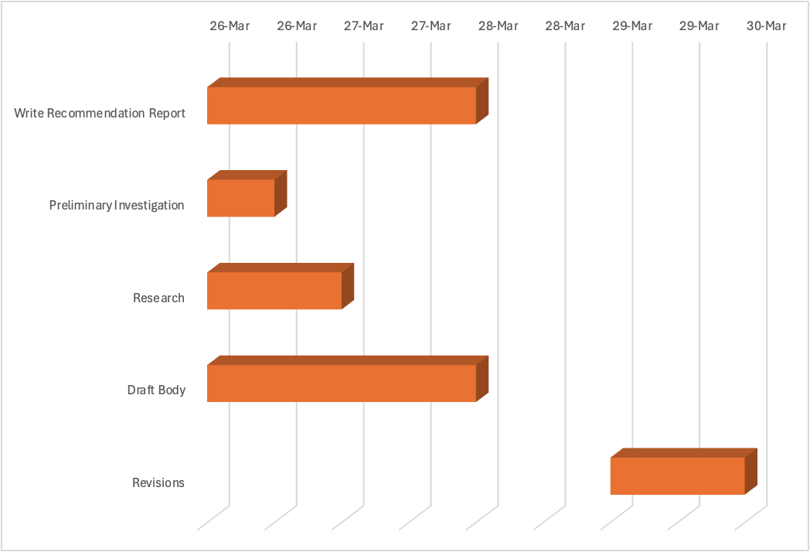

# Conclusion

Through efforts to improve HokieSpa’s usability, our team aims to address and solve the key pain points that affect Virginia Tech’s students, faculty, and staff. We will use research, user feedback, and webpage information to propose rational improvements to the platform’s navigation, technology, and optimization. These updates will advance HokieSpa’s efficiency and accessibility, and elevate the university’s digital presence.

Our team is dedicated to mastering our roles and responsibilities and will use each other’s strengths to our advantage. Our collaborative efforts in meetings and communication will provide us with a manageable timetable to complete our work.

Our team looks forward to receiving your feedback on our proposal. We look forward to continuing our research. If you have any questions about our proposal and our efforts to improve the usability of *HokieSpa*, please contact [vardaan7@vt.edu.](mailto:vardaan7@vt.edu)